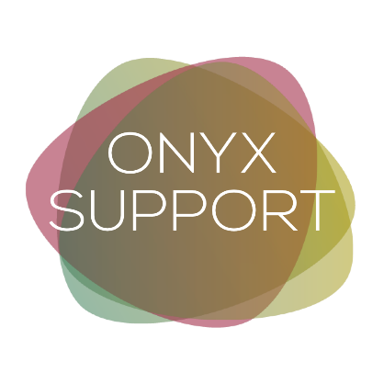
Building Discrepancy
Explore how your life will change if you choose to either continue or quit using drugs or alcohol…

My career, school or professional life will be affected…
If I continue using: | If I quit using:

My long—term goals will be affected…
If I continue using: | If I quit using:

My relationships with my friends will be affected…
If I continue using: | If I quit using:

My relationships with my family and other loved ones will be affected…
If I continue using: | If I quit using:

My finances will be affected…
If I continue using: | If I quit using:

My health will be affected…
If I continue using: | If I quit using:

